**CC LAB TEST**

**Round Robin:**

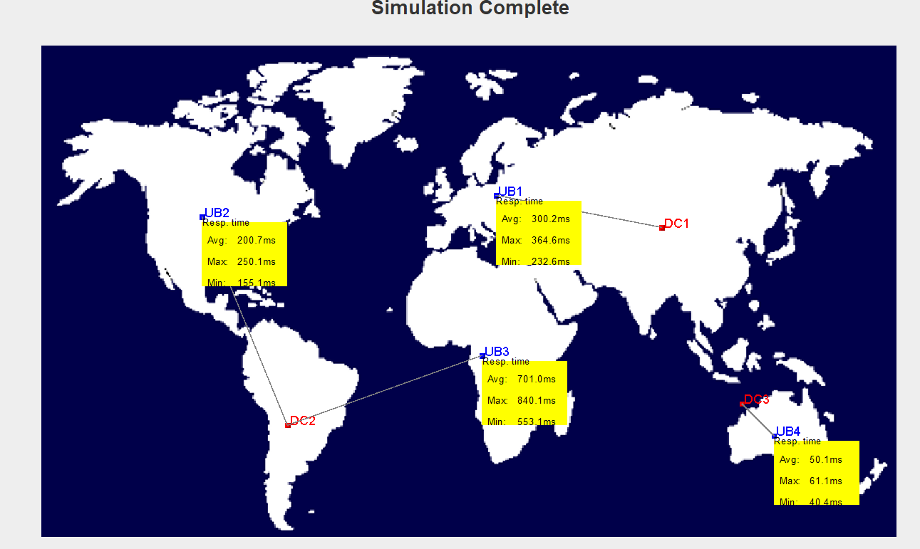

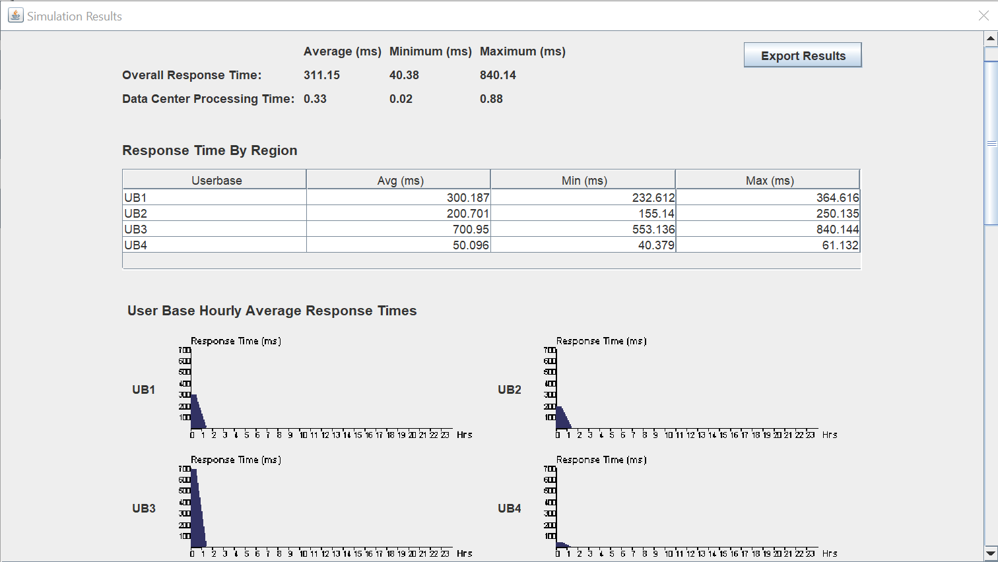

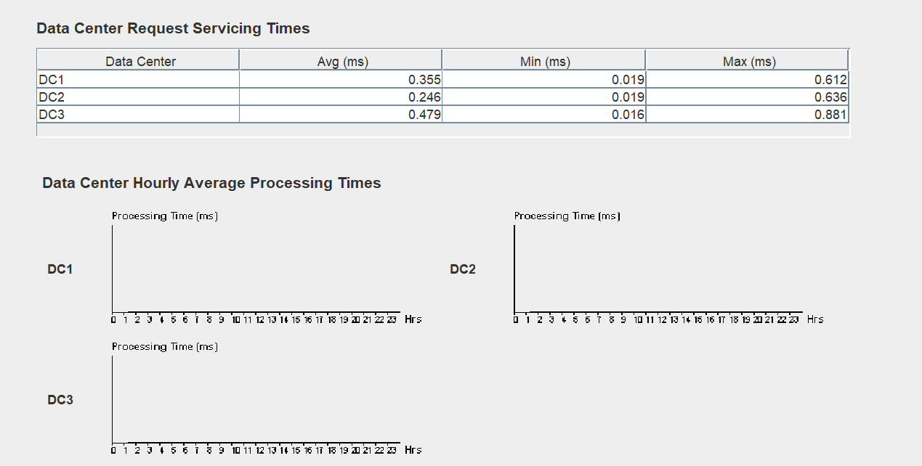

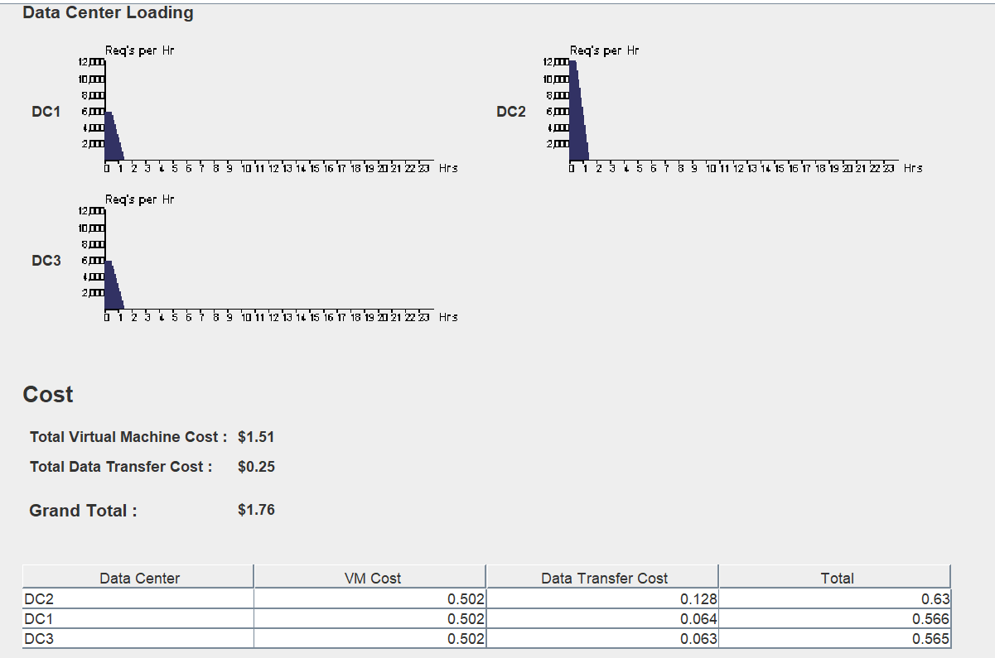

**Equally current execution load:**

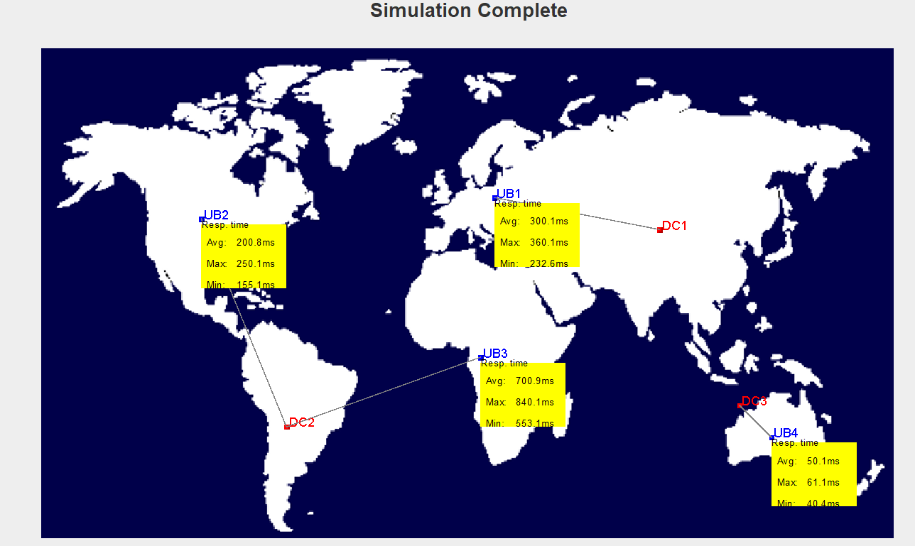

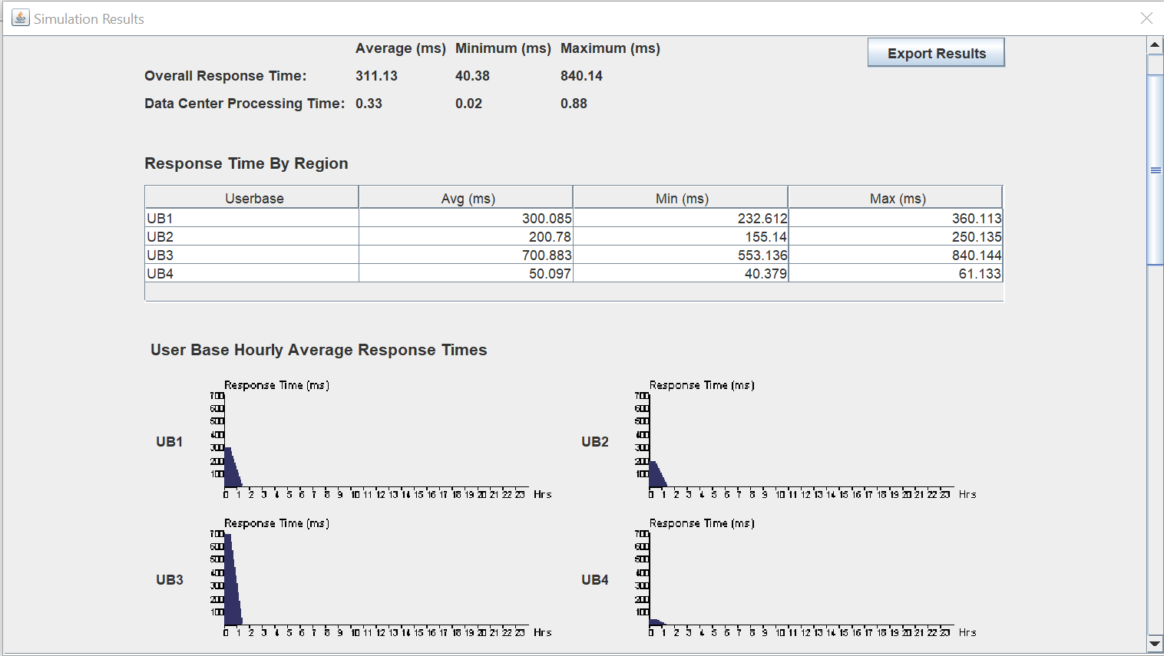

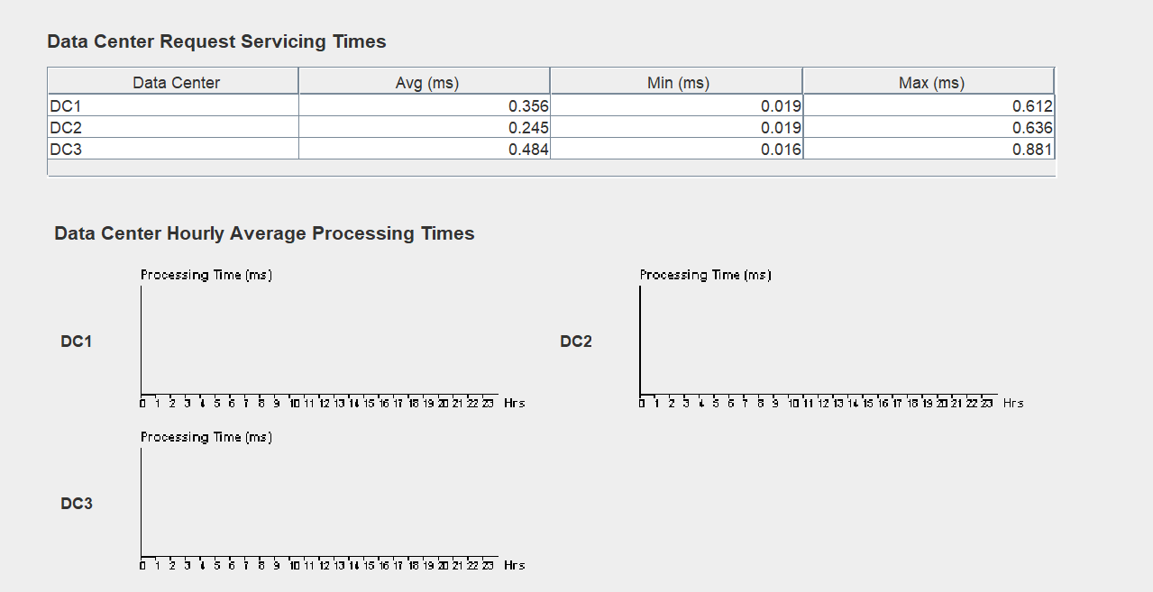

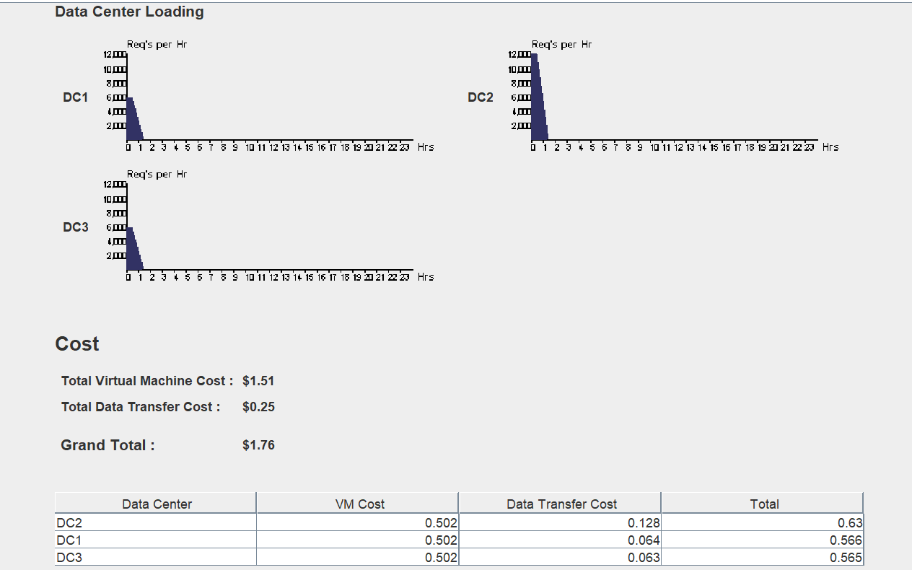

**Throttled:**

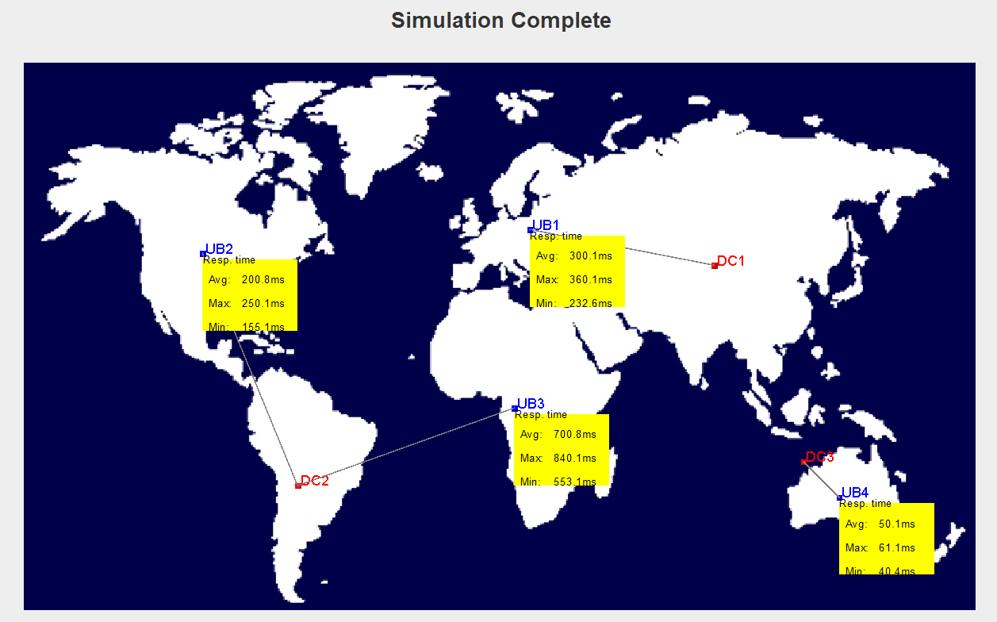

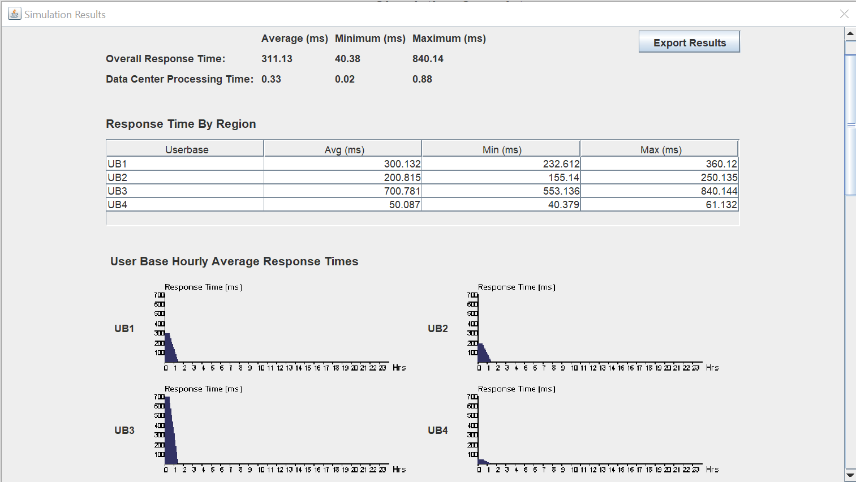

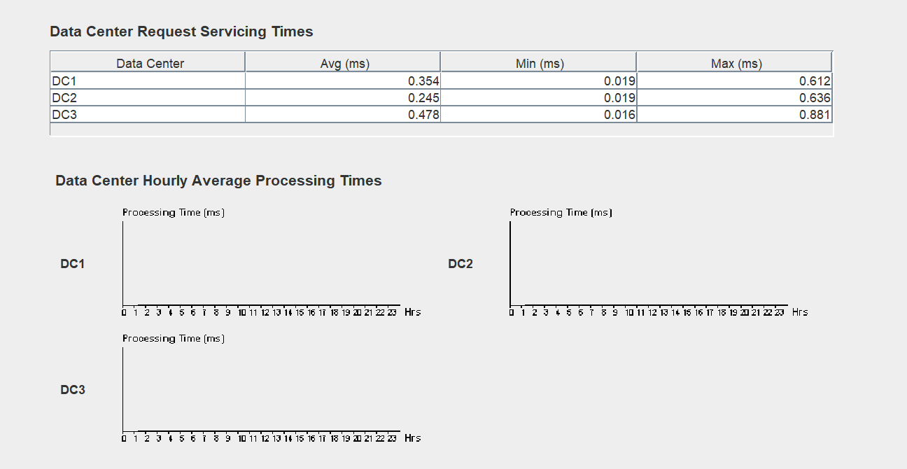

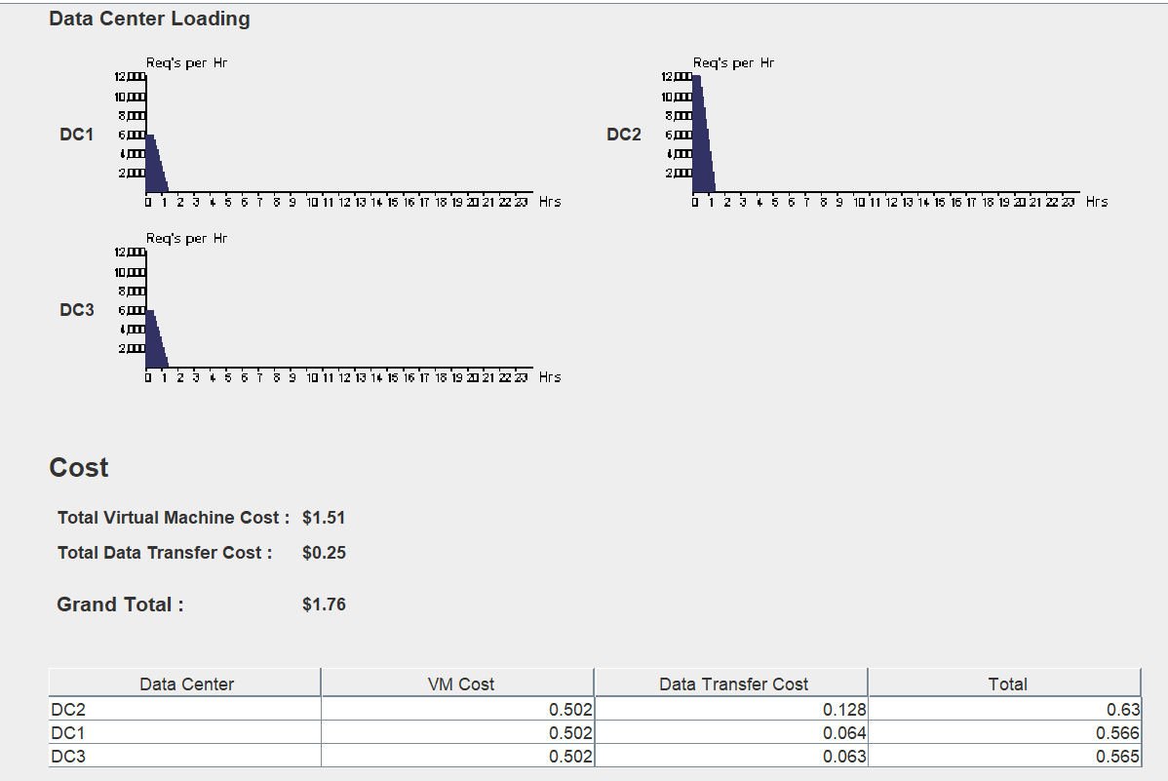

Observation:

Here are some observations you might encounter when running simulations in Cloud Analyst using Round Robin, Equally Spread Current Execution (ESCE), and Throttled scheduling algorithms for a data center and userbase:

**Round Robin**:

* ****Fairness:**** This algorithm ensures fair allocation of resources to all VMs by distributing tasks in a cyclical manner. No single VM gets overloaded, leading to potentially balanced response times for user requests.
* ****Potential inefficiency:**** Since Round Robin doesn't consider the current load on VMs, it might assign tasks to already busy VMs, leading to increased waiting times if the workload isn't evenly distributed.

****Equally Spread Current Execution (ESCE):****

* ****Improved balancing:**** ESCE tries to distribute tasks more evenly based on the current number of active tasks on each VM. This can lead to better resource utilization and potentially lower average waiting times compared to Round Robin.
* ****Overhead:**** Determining the current load on each VM might introduce some overhead, potentially impacting performance in highly dynamic scenarios.

**Throttled:**

* ****Reduced congestion:**** This algorithm prevents overloading VMs by setting a threshold for active tasks. If all VMs reach the threshold, new requests are queued until a VM becomes available. This can help avoid excessive waiting times and improve overall system stability.
* ****Potential delays:**** Throttling might introduce delays for user requests if the workload exceeds the available capacity, leading to longer queueing times. Finding the right throttling threshold is crucial for balancing responsiveness and resource utilization.

**Write down a note on cloud analyst?**

A Cloud Analyst is a technology professional who specializes in assessing, managing, and optimizing cloud computing resources and services for organizations. They play a crucial role in helping businesses leverage the benefits of cloud computing efficiently and cost-effectively.

* ****Planning and Design:****
  + Analyze business needs and recommend suitable cloud solutions.
  + Design, implement, and configure cloud infrastructure and applications.
  + Select appropriate cloud service providers (CSPs) based on requirements and budget.
* ****Optimization and Management:****
  + Monitor and analyze cloud resource utilization.
  + Identify cost-saving opportunities and implement optimization strategies.
  + Manage cloud security, compliance, and disaster recovery measures.
* ****Data Analysis and Reporting:****
  + Analyze cloud usage data to identify trends and insights.
  + Generate reports to inform decision-making and track performance metrics.
  + Collaborate with other teams (e.g., data scientists, business analysts) to leverage cloud data for strategic purposes.

Name: Mayank Agrawal

Roll No.: 21052601